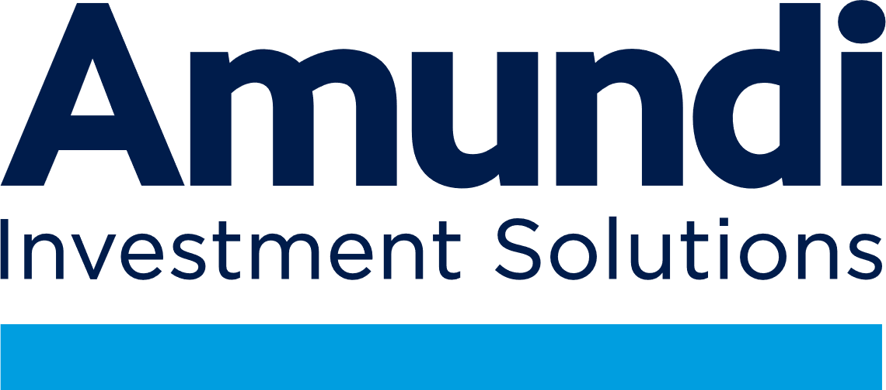

**Press release**

**2024 Mid-Year Global Investment Outlook:**

**Multi-speed growth with diverging dynamics**

**Paris, 11 July 2024**

* **Global growth is expected to reach 3.1% in 2024 and 3% in 2025. Inflation should normalise in 2025, enabling major central banks to proceed with rate cuts, but not all at the same time. A new spike in inflation in the wake of the US election is a tail risk investors should be mindful of.**
* **Geopolitical risk will increase in the years ahead, in particular for US-China relations. Europe will have to reassess its approach to China and focus on its own strategic priorities, such as defence, energy transition and resilience of supply chains.**
* **Investors should seize historical opportunities in bonds and broaden their equity and EM investment universe. Commodities and real and alternative assets can offer diversification and enhance portfolios’ risk-return profiles.**

Amundi expects a multi-speed growth in the second half of 2024, marked by slow and uneven disinflationary trends and diverging dynamics. Geopolitical risk is high, and rising, with trade-related factors intensifying and driving higher commodity prices.

**Vincent Mortier, Group CIO of Amundi, said**: *“The economic context supports earnings and risky assets, but most of the upside potential is already priced in and finding clear catalysts for further gains will be challenging. To navigate the uncertain transition into the next phase of the cycle, we favour high-quality equities, a positive duration stance, and commodities to hedge against inflation risk.”*

**Monica Defend, Head of Amundi Investment Institute, added*:*** *“With decelerating but sticky inflation and multi-speed growth, central banks will need to carefully assess their stance and communication. Their actions may not be synchronised, but we expect any divergences to be limited.”*

**CENTRAL SCENARIO: LATE CYCLE WITH DECENT GROWTH AND NORMALISING INFLATION**

While the global economic outlook appears increasingly fragmented, we still consider that restrictive monetary policies and fading fiscal expansion are curbing inflation and growth, without triggering a recession in the main regions.

We forecast a mild deceleration of global GDP growth to 3.1% in 2024 and 3% in 2025, from 3.2% in 2023. The US economy will decelerate (2.3% and 1.7%) while the Eurozone is recovering (0.8% and 1.2%). Developed markets will remain broadly stable (1.5% in 2024 and 2025) and Emerging markets (EM) resilient overall (4.2% and 4.0%). India will maintain strong growth (6.6% and 6.2%) and China should manage its controlled slowdown (4.8% and 3.7%).

Elections in France and in the UK have not altered our growth forecasts for these countries for the time being, and we continue to expect a gradual economic recovery in both cases (0.9% for 2024 and 1.3% for 2025 for France / 0.8% for 2024 and 1.3% for 2025 for the UK).

Inflation is stickier than expected but should further decelerate towards central bank targets in 2025. This will allow major central banks to proceed with a new cycle of cuts to avoid an excessive slowdown, though at different speeds. Economic fundamentals support easing in most EM countries, as long as the Fed does not raise rates. Our base case is that the Fed will begin cutting rates by September 2024. A less likely downside scenario would be a renewed spike in inflation in the wake of the US election.

Geopolitical risk is expected to increase in the coming years, with factors such as protectionism, sanctions, tariffs, export controls, and trade wars intensifying. The outcome of the US election will be pivotal, as US foreign policy should significantly differ under a Biden vs Trump presidency. Nevertheless, US confrontation with China is expected to rise and Europe will need to assess its approach to China because of its own priorities in defence, resilience of supply chains, and the energy transition.

**INVESTMENT IMPLICATIONS: DYNAMIC ALLOCATION IN A LATE CYCLE**

To navigate the transition to the next phase of this cycle, asset allocation should withstand different scenarios and balance opportunities in supportive earnings dynamics and appealing bond yields versus high uncertainty about growth, inflation, and geopolitical risks.

This means investors should combine a mildly positive equity stance with a long duration bias and search for additional sources of diversification.Theyshould also assess geopolitical and idiosyncratic risks, and look for companies that will help drive the energy transition in both developed and emerging markets.

Overall, we favour high-quality equities, maintain a positive duration stance, and look at commodities as a hedge against inflation. We are neutral on China and seek opportunities in structural EM stories such as India, Indonesia, South Korea. In advanced markets, we look for areas that could benefit from the economic recovery at reasonable prices and remain wary of concertation risk.We expect broad-based capitalization-weighted indices will remain in narrow ranges (-5%/+5%) in H2 2024, before entering into a more volatile sequence.

* **Equities: avoid concentration risk and focus on quality and value.** Opportunities abound in US quality, value, and global equity. Consider European small-caps to capitalise on the economic cycle recovery and attractive valuations. Regarding sectors, our stance is balanced between defensives and cyclicals at the bottom of the trading range. We are more positive on financials, communication services, industrials and healthcare.
* **EM equities** offer interesting opportunities and relatively attractive valuations compared to the US. We favour Latam and Asia, with India in focus thanks to its robust growth and transformative trajectory.
* **Bonds: seize historical opportunities and prepare for structural steepening.** Amid still high volatility in this disinflation phase, we favour government bonds and investment grade credit. **EM bonds** will benefit from Fed easing, and local currency bonds will become attractive as the US dollar weakens.
* **Diversification: commodities and real and alternative assets**, including hedge funds, will enhance portfolios’ risk-return profiles. Commodities, **metals** in particular, will be increasingly exposed to geopolitics and structural themes such as the energy transition. Supply/demand dynamics will weigh on **oil** which we target at $80/barrel over the next 12 months. Diversification away from the dollar should keep supporting **Gold,** which we expect to reach $2500/oz.
* **Currencies:** despite few alternatives in the short term, we expect the USD to weaken as US growth decelerates and the Fed eases, while the EUR and the GBP should regain strength. In EM, we favour ultra-high yielding currencies such as those of Brazil, Mexico, Peru, Indonesia, and India.

|  |  |
| --- | --- |
| **Press contacts:**  Danae Quek, Amundi  Tel: +44 20 7190 2044  [danae.quek@amundi.com](mailto:danae.quek@amundi.com)  [servicepresse@amundi.com](mailto:servicepresse@amundi.com) | Armelle Sens, Amundi Investment Institute  Tel: +33 (0) 6 1902 3319  [armelle.sens@amundi.com](mailto:armelle.sens@amundi.com) |

**About Amundi**

Amundi, the leading European asset manager, ranking among the top 10 global players[1], offers its 100 million clients - retail, institutional and corporate - a complete range of savings and investment solutions in active and passive management, in traditional or real assets. This offering is enhanced with IT tools and services to cover the entire savings value chain. A subsidiary of the Crédit Agricole group and listed on the stock exchange, Amundi currently manages more than €2.1 trillion of assets[2].

With its six international investment hubs[3], financial and extra-financial research capabilities and long-standing commitment to responsible investment, Amundi is a key player in the asset management landscape.

Amundi clients benefit from the expertise and advice of 5,500 employees in 35 countries.

***Amundi, a trusted partner, working every day in the interest of its clients and society***

[www.amundi.com](http://www.amundi.com/) [](https://www.linkedin.com/authwall?trk=ripf&trkInfo=AQFJx8hIeb9DPwAAAWpJ0i0AQYek_zss8WhaNd4TUxcccnR_LV5rAUmOgdHt754MKdwCBAQ7DkDfFoxr1V06TXhuTmsTUDVdPQ7yUCgmMTwFut2SXoGAIMhw_shKKvs_eH5P8bI=&originalReferer=https://www.google.fr/url?sa=t&rct=j&q=&esrc=s&source=web&cd=2&ved=2ahUKEwjiuNCEhubhAhUF1eAKHcsuBe0QFjABegQIBRAB&url=https%3A%2F%2Fwww.linkedin.com%2Fcompany%2Famundi-&usg=AOvVaw157F-YwWbMr7Ccr16q53N7&sessionRedirect=https%3A%2F%2Fwww.linkedin.com%2Fcompany%2Famundi-) [](https://twitter.com/Amundi_ENG) [](https://www.facebook.com/AmundiOfficial/?fref=ts)

1. *Source: IPE “Top 500 Asset Managers” published in June 2024, based on assets under management as at 31/12/2023*
2. *Amundi data as at 31/03/2024*
3. *Boston, Dublin, London, Milan, Paris and Tokyo*